Yifan Yang 40038814

(a)S->S1|S2

S1->abS1d|F

F->cFd|λ

S2->abS2d|G

G->abGc|λ

(b)S->S1|S2

S1->S3aS3

S3->aS3b|bS3a|S3S3|A

A->aA|λ

S2->S4bS4

S4->aS4b|bS4a|S4S4|B

B->bB|λ

(c) S → aSFSFS|FSaSFS|FSFSaS|λ

F → b|c.

2.(a)

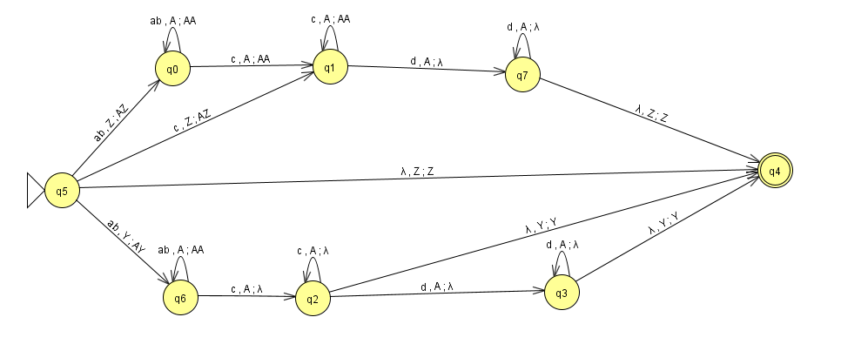

Z base is I+J=K

Y base is I=J+K

(b)

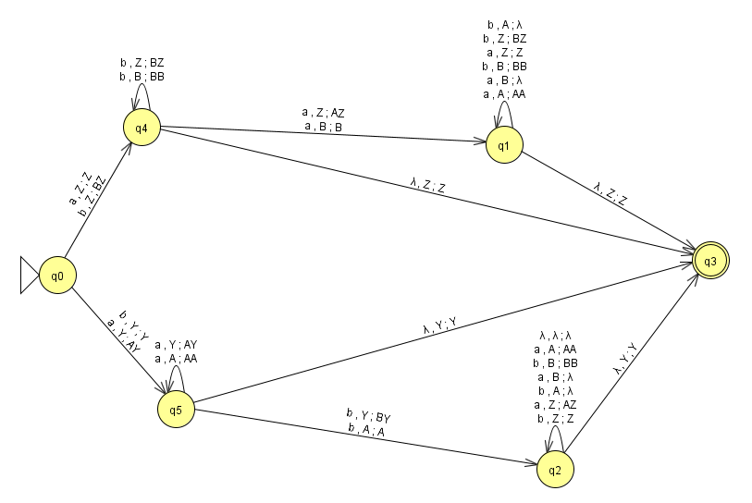

Z base is number of a>number of b

Y base is <

(c)

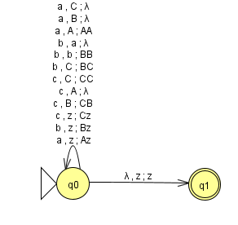

3.(A)

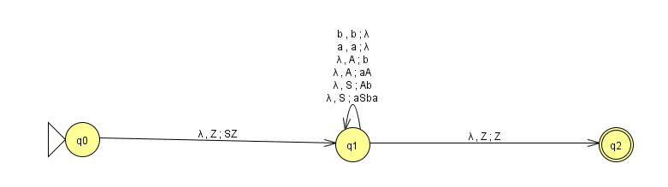

(B)

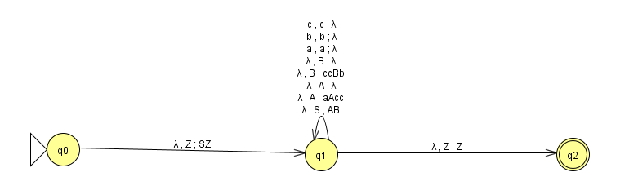

4.

(a)S->Sb->aaSbb->aabbb

S->aaSb->aaSbb->aabbb

two diffrent way two get same aabbb

(b)L={a2nbn+m:n>=0,b>=1}

(c)S->Sb|ASb|b

(C) S->Sb|T

T->aaSb|b

5.

｛S｝,｛a,b｝

S->aS|bS|λ

6.(a)

S->AX|BY|a|b

X->SB

Y->SA

B->b

A->a

(b)

S-> aP bQRaT|aS|Rb

P->PQR|aP|PbT|入

Q->R|bQ |入

R->aSb|S|入

T->ab

S-> aP bQRaT|aS|Rb|abQRaT|aPbRaT|aPbQaT|abRaT|abQaT|aPbaT|abaT|b

P->PQR|aP|PbT|PR|P|PQ|QR|Q|R|a|aP|PbT|bT

Q->R|bQ

R->aSb|S

T->ab

S->BaPBbQRBaT|BaS|RBb|BaBbQRBaT|BaPBbRBaT|BaPBbQBaT|BaBbRBaT|BaBbQBaT|BaPBbBaT|BaBbBaT|b

P->PQR|BaP|PBbT|PR|P|PQ|QR|Q|R|a|BaP|PBbT|BbT

Q->R|BbQ

R->BaSBb|S

T->BaBb

S->NV|BaS|RBb|TV|NW|NX|TW|TX|NU|TU|b

P->PO|BaP|YT|PR|P|PQ|O|Q|R|a|M|YT|BbT

Q->R|BbQ

R->ZBb|S

T->BaBb

M->BaP

N->MBb

O->QR

U->BaT

V->OU

W->RU

X->QU

Y->PBb

Z->BaS

Ba->a

Bb->b.

7. when n=1, there is only root, |w| <=2^0=1 ,true

when n=k. assume |w|<=2^k-1

then when n=k+1, every outer node will be turned into inner node and can at most have most 2 outer node,so with 2^k-1 inner node,we can create 2^k outer node.

8.

 take your grammar in CNF and for every production A→BC add productions Aλ→BCλ and Aλ→Bε. Also, for every A→a add a Aλ→a. Finally change the starting symbol to Sλ and add Sλ→λ. Now any derivation tree will have some Xλ as the rightmost symbol and it will thus be possible to terminate it at any step.